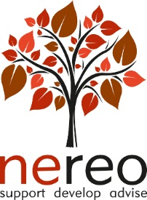

OD NETWORK

MONDAY 12 JUNE 2023 (1.30pm – 4.30pm)

TEAMS MEETING

AGENDA

Facilitators : Lucy Ord and Mandi Sherlock-Storey

We are excited to be hosting the first of NEREO’s new style OD Network events which will offer both a space for considering a topical OD issue followed by the opportunity to participate in a peer supervision session. You have the option to stay for the whole 3-hour session or to join one or other of the Topical/CPD slot (1 hour 15) or Peer Supervision session (1 hour 30). See schedule below.

Please note you do not have to have a specific issue or challenge to bring to supervision to benefit from participation in the supervision session. Past participants have consistently confirmed the value of learning from hearing and discussing other’s challenges as well as the inclusion of plenary sharing re. OD challenges currently encountered.

We look forward to seeing you at the session.

Schedule :

1.30 – 2.45 pm Topical/CPD slot – Exploring our OD work and using an OD lens

2.45 - 3.00 pm Break

3.00 - 4.30 pm Peer supervision session

